 Final Year Project - UG

**School of Computer Science and Engineering (SCOPE)**

**B.Tech. CSE Capstone Project** **In-house student Initial Review by Guide**



**Program: B.Tech. CSE Batch: 2020-21 Course Code: CSE4099**

**Register No.:17BCE1325 Name of the Student: Shashanka Shekhar Das Mobile No.8638569010**



|  |  |  |  |
| --- | --- | --- | --- |
| **Project Title:**  **AI GENERATED HIGH PROBABILITY PATH OF FINANCIAL SUCCESS AND CALCULATION OF ASSOCIATED RISK** | | | |
| **Complete Plan for Project Implementation :**  Health Insurance prediction and choosing will be done by data collection, grading and creating methods for users to prioritize different factors according to their liking. The calculators will be done by gathering datasets or required formulas. Investing to get good returns with user dependent risk will be done by using data provided by API’s, using a combination of ML/AI models and existing research to calculate the percentage of an investment type in the portfolio to get risks closer to the users liking. Savings for emergency would depend upon the emergency and hence the liquidity and the mode of investment will be predicted by the investment class. Creating calendars would require the date of the expense and the expense amount, then a UI to mark the date. Planning for these expenses will also be done by the Investment Class.  Upon registration, data will be collected on a variety of different factors and these will generate the next steps for the user to take. These data will be fed to a ML/AI model which will predict the best moves.  The UI for the website will be created using Django and associated web technologies. | | | |
| Ability to articulate the problem and Identify Objectives: | | | **Poor / Fair / Better / Excellent** |
| Ability to determine the right use of technology to achieve the identified objectives: | | | **Poor / Fair / Better / Excellent** |
| Ability to identify and compare related technology that can be used to realize the identified objectives: | | | **Poor / Fair / Better / Excellent** |
| Ability to use the basics of Science to explain the Engineering / Design Principles and the Technology used: | | | **Poor / Fair / Better / Excellent** |
| Ability to meet realistic constraints & Implementation steps taken with proper references: | | | **Poor / Fair / Better / Excellent** |
| **Aiming for** | Product Development / Patent / Scopus Indexed Journal Paper / International Conference Paper | | |
| **Work Status** | ***Excellent / Good / Satisfactory / Needs improve*** | | |
| ***Attendance Status*** | **Regular / Irregular** | ***CAM – Max. 5 Marks per week*** | |

**Signature of the Student with date Name & Signature of the Guide with date (digital)**

**Problem Statement:**

Financial Security in the present day and age is one of the most important but underrated skills. Managing your money to guarantee a life of comfort and avoid hardships associated with money is one of the most important skills, there have been innumerable examples of rich people losing everything and everyday people retiring with a lot of money. This project will not guarantee the best returns but will try to guarantee decent returns with minimal risk associated.

**Project Objectives:**

* To create an app to understand the needs and predict the amount to be saved in terms of health insurance and identify the policy to be chosen based on several user chosen criterias.
* To create several calculators to calculate different variables like amount to save for retirement, amount to save per month, amount to save for insurance and amount to save for education.
* To create a calendar to show all upcoming expenses, plan and save for expenses.
* To create a plan to save for unplanned financial emergencies like job loss, starting a business or any other emergency.
* To create an investment plan to give returns above what other forms of investments like PF, FD, Bank Account etc. The risk appetite of the user will define the percentage returns.

**Feasibility Study:**

1. **Technical Feasibility**

All the technologies used in the project are available freely and are open source or free. The API’s used in the project are freely available.

1. **Financial Feasibility**

The project uses Open Source and/or free software. The data to be used in the project is free but using it for retail purposes is not covered in the license. Selling or using the API in a project used by a large group will need a paid license, which for Bombay Stock Exchange is ₹20 lakh + taxes.

1. **Duration feasibility**

The individual parts and the integration of all parts along with testing will be completed before the 3rd Week of May, 2021.

**Existing System:**

There are websites to choose health insurance policies, like *policybazar* but the main factor of consideration in these sites are the Coverage Amount, Coverage Hospitals and Yearly Premium.

There are sites, articles and TV shows regularly which suggest stock to buy, sell or hold based on research done by their team. The choices done by these usually don’t usually consider the long term needs or risk appetite of the user.

There are calculators which calculate requisite variables using standard and/or fixed variables like Value of Money, Retirement Savings Calculator etc.

**Proposed Model:**

There have been numerous studies and online tools covering some portions of our project, for health insurance there exists tools like policybazar to compare and buy insurance. Our model will take into consideration many more factors which will best suit the user (and/or his family). Our implementation for health insurance considers a sum total of 7 factors. The choice of the suggested insurance will depend on the data submitted by the user during account creation and also on the criterias selected by the user.

The calculators in the project will calculate the necessary values but in some instances will use Machine Learning to give an accurate prediction of the values.

The data collected to be used for prediction to invest in the Stock Market, will be collected using Open Source APIs for NSE and BSE. The prediction to buy and what percentage of portfolio to allot for Equity, Mutual Funds, Bonds etc will be done upon the need, duration and risk appetite of the user.

Tracking and preparation of expenses will be done using the calendar class, the date of expense will be shown in the UI and preparation for the upcoming expense will depend upon several factors.

During the registration, the user will be required to fill several data, these data will be fed to different modules and also to the AI model which predicts the steps to be taken after registration.

**Literature Review:**

[1] This paper determines the financial literacy in India by asking people a set of questions and grading the results. The set of people questioned belong to several different demographics and the results of the research isn’t too promising, 37% of surveyed citizens belong to the category of High Financial Literacy, while 19% have a very low level of literacy.

[2] [3] These papers determine the awareness and feelings of financial security among women. Among the surveyed women in Pune, 85% of women are aware of investments while only 35% among the 85% are ready to take any risks in investments, 65% of the 85% prefer traditional modes of investment like FDs and Post Office Schemes. [2] surveys American women and feelings towards Financial Security, the answers are similar, financial security aspects like Retirement, buying assets and saving for health are a sum total of 20.16% of total thoughts in a women’s mind.

[4] This paper aims to find how financially literate college students are in India and concluded that the financial literacy is low and commented that an increase in financial literacy will act as a preventive measure against falling for frauds and scams.

[5] This paper researches the awareness of Mutual Fund Investment in India and the results are bleak, among a total of 100 people, only 15 were fully aware of mutual funds whereas 44 were partially aware.[6] This paper evaluates the return on Small Cap Mutual funds over a period of 5 years (2014 - 2018) and finds average returns of 10 considered funds to be between 8% to 30%. The year 2018 shows the high volatility of Small Cap Funds with returns in negative for all funds.

[7] This study shows Financial Security options for Indians, it was seen that 95% of citizens used Bank Deposits as a measure of savings. Precious metals were seen as savings for 30% of citizens, real estates at 16.5% whereas traditionally higher risk modes of investments like Equity were chosen by 8%, this number is the same as those choosing pension schemes. At Least one life insurance was purchased by 61%. The same study that on average 44% of total savings of a household was in deposits, which traditionally are low risk low yield investments and quite often are beaten by inflation, insurance is on 19% while government schemes and pension funds are 4% and 14% respectively, which Equity accounts for 13%.

**UML Diagrams :**

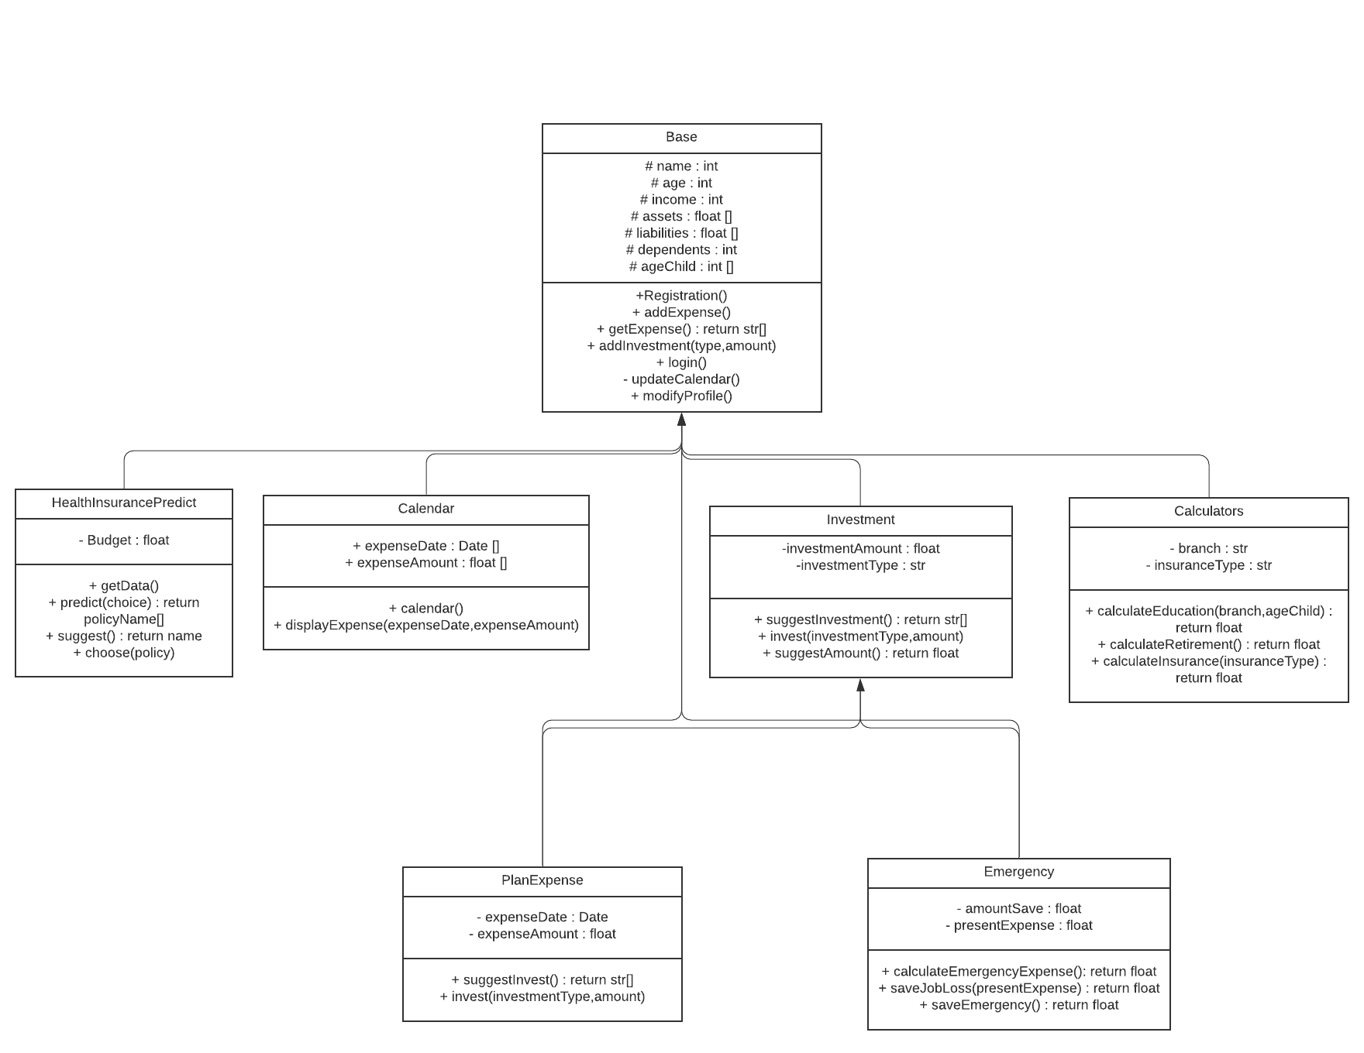

*Fig 1 : Class diagram*

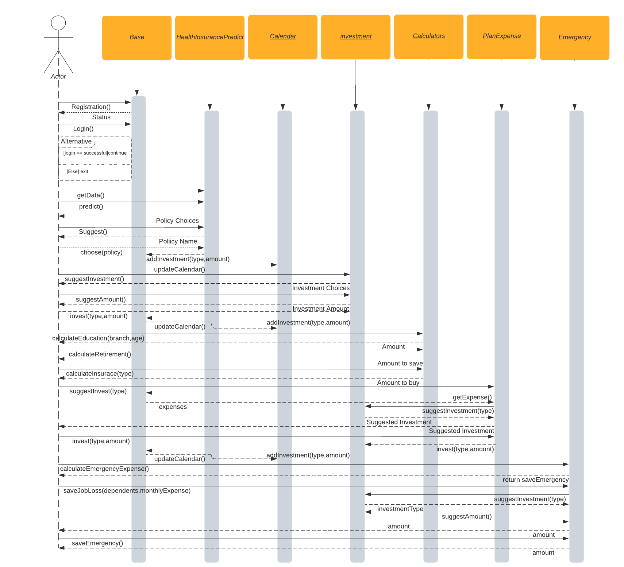

*Fig 2 : Sequence Diagram*

**Reference:**

[1] Kapil Choudhary & Samriti Kamboj (2017), “A STUDY OF FINANCIAL LITERACY AND ITS DETERMINANTS: EVIDENCE FROM INDIA “,Asian Journal of Accounting Perspectives · December 2017

[2] Talya Miron-Shatz(2009), ““Am I going to be happy and financially stable?”: How American women feel when they think about financial security”, Judgment and Decision Making, Vol. 4, No. 1, February 2009,

[3] Prof. Priya Vasagadekar(2014), “A RESEARCH PAPER ON INVESTMENT AWARENESS AMONG INDIAN WORKING WOMEN WITH REFERENCE TO PUNE REGION”,International Journal of Scientific & Engineering Research, Volume 5, Issue 6, June-2014

[4] Dilip Ambarkhane, Bhama Venkataramani andArdhendu Shekhar Singh (2015), “Financial Literacy Index forCollege Students”, Annual Research Journal of Symbiosis Centre for Management Studies, PuneVol. 3, April 2015

[5] Reshma Raju Mini (2020), “A Study On The Awareness Of Mutual Funds Investment In India”, INTERNATIONAL JOURNAL OF SCIENTIFIC & TECHNOLOGY RESEARCH VOLUME 9, ISSUE 01, JANUARY 2020

[6] Prof. Sumant L. Wachasunder(2018), “A Study on the Performance of Equity Mutual Funds With special reference to small cap mutual funds”, 2018 JETIR October 2018, Volume 5, Issue 1

[7] Crisil, “Financial security for India’s elderly”